**Analysis and Design of Algorithms**

**Semester III**, Year **2021-22**

**Lab - 3**  Date : 06-10-2021

Name: E. Sai Manoj MIS. No: 112015044 Branch: CSE

**AIM:**

1. Create a binary search tree by reading the inputs from file ’numbers.txt’. Display the inorder walk of the tree.

2. Compute the lowest common ancestor of binary search tree. Take the input from user after displaying the binary tree (in -order walk)

**Question 1:**

**Pseudo Code:**

Define/Create a Binary Search Tree

Input values

Define a Inorder function to print values in Inorder Traversal

START

inorder(p : pointer to a tree node)

if p != nullptr

inorder(p->left)

Visit the node pointed to by p

inorder(p->right)

end if

end procedure

END

**Output:**

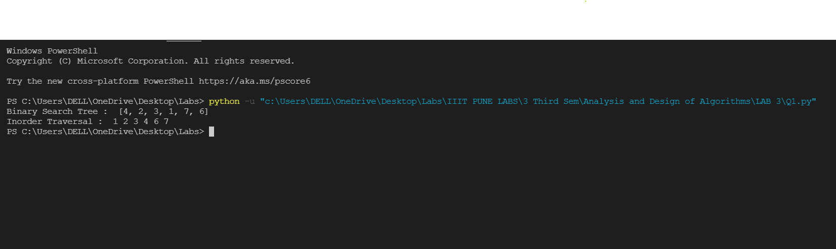

**Question 2:**

**Pseudo Code:**

Define/Create a Binary Search Tree

Input values

Define a function to print values in Inorder Traversal

Display Inorder traversal of Tree

Define a function to find Lowest Common Ancestor of user inputted values

Take input from user for finding Lowest Common Ancestor

START

lowestCommonAncestor(root, v1, v2) {

node = root

if node is None:

return None

if node.val > v1 and node.val > v2:

return lowestCommonAncestor(node.left,v1,v2)

elif node.val < v1 and node.val < v2:

return lowestCommonAncestor(node.right,v1,v2)

else

return node

}

END

(*node.val is current node; v1, v2 are user inputted values)

**Output:**

